February 6, 2019 Oversight Hearing for
Office of Deputy Mayor for Health & Human Services

Testimony Submitted by Marcia Bernbaum, Mentor & Advisor to the
People for Fairness Coalition (PFFC)
Downtown DC Public Restroom Initiative

Good morning Health Committee Chair Gray, members of the Committee on Health, Acting Deputy Mayor for Health & Human Services Turnage. My name is Marcia Bernbaum. I serve as mentor and advisor to the People for Fairness Coalition (PFFC) Downtown DC Public Restroom Initiative.

Before I begin, I would like to extend my appreciation to you, Council Member Gray, for marshalling Bill 22-0223, Public Restroom Facilities & Installation Act of 2018, through the Committee on Health and from there to the floor of the Council of the Whole where the bill received unanimous voice votes on December 4 and 18, 2018. Bill 22-0223 was sent to the Mayor in January. We believe that Bill 22-0223 has left the Mayor’s desk and has gone to the Congress for review before being returned to the Mayor to be signed it into law.

I chose to testify at today’s oversight hearing because the Deputy Mayor’s Office for Health and Human Services oversees the Department of Health, the Department of Human Services, and Age-Friendly DC. While everyone needs ready access to clean, safe public restrooms when nature calls, three populations are in particular need. All three are within the Deputy Mayor’s purview:

- People who experience homelessness are often turned away from private facilities with restrooms during the day and, at late at night, have no choice but to urinate/defecate outside because no restrooms. If caught, they risk a fine of up to $500, 90 days in jail, or both. They also risk acquiring a criminal record that will make it more difficult to find affordable housing and employment.

- Individuals with a number of health conditions that cause them to have to go urgently when the need arises. This includes, but is not limited to, individuals: with crohn’s & colitis disease, who suffer from diabetes, who have bowel incontinence, who take medication to reduce blood pressure which has a diuretic effect, and many individuals who have suffered strokes.

- Seniors, a group of which I am a member: as we age our bladders become smaller causing us to have to the urge to find a restroom more frequently when nature calls. This is exacerbated by involuntary bladder contractions and fecal incontinence which become more frequent as many of us age.

An unfortunate consequence for people who suffer from intermittent or chronic conditions that cause them to need to use a restroom frequently is that this limits their choice of shopping locations. It also limits their participation in physical fitness activities as many will not choose to leave the houses to exercise or visit parks unless they are sure they can find a clean, safe public restrooms when they have that sudden urge.

Capitals in Europe and Asia recognize the importance – from a public health, personal health, and business perspective, -- and have taken steps to invest in clean, safe public restrooms that are readily accessible to shoppers, walkers, joggers, and tourists in their downtown areas. They also make information available to the public on where they can find public restrooms.

By way of contrast, if you are in downtown DC and you are outside of the Mall, you will have a very difficult time finding a clean, safe public restroom. There are only two public restrooms open 24/7 in all of Washington DC -- the Lincoln and Jefferson Memorials, both of the beaten track when you are downtown late at night, all restaurants and bars are closed, and there is nowhere nearby to go. And there are five public restrooms downtown that are open during the day. Two are located near the White House– at Lafayette Square and the White House Visitor’s Center. Three are located near Gallery Place - the National Portrait Gallery, the National Building Museum. There are no signs to direct you to any of these restrooms.

The passage of Bill 22-0223 paves the way for our Nation’s Capital to join other European and Asian Capitals who are known for having gone out of their way to install and maintain clean, safe public restrooms in heavily trafficked areas and provide signage to tell you where they are when nature calls. We are looking forward to having the Mayor include $336,000 in her FY 2020 Budget for the first year of the two pilots provided for under the bill.

Bill 22-022 directs the Mayor to form a working group -- composed of representatives from the Departments of Public Works, General Services, Health, Human Services, Transportation, Parks & Recreation, DC Water, an expert in urban planning, and 4 representatives from non-profit organizations that support seniors, the homeless, and issues related to health -- that will be tasked with:

- Assessing the feasibility of installing clean, safe public restrooms in DC
- Identifying an appropriate model for a stand-alone public restroom open 24/7 that is clean, safe, discourages illicit use, is economical, and easy to maintain; along with appropriate sites where they are need near water and sewer connections, have community buy-in and support, and maximize safety.
- A program to provide incentives to private businesses to make their restrooms available to the public during the hours they are open, patterned on successful experience in England with the Community Toilet Scheme.

Bill 22-0223 was inspired by, and its contents are drawn from, our research. The criteria for selecting the most appropriate stand-alone public restrooms and their locations are drawn from research we have done lessons learned and best practices in other cities in the US that have been successful in recent years in installing and maintaining clean, safe, economical public restrooms open 24/7. Similarly, the guidelines for incentivizing businesses to open their restrooms to the public are drawn from best practices in operating the Community Toilet Scheme that are available in boroughs throughout England. You can find our research on our website: www.pffcdc.org/what-we-do/public-restrooms.

I am attaching to this testimony:

- The information sources used to document the personal and public health hazards and consequences of limited access to restrooms.
- Lessons learned from cities that have successfully installed and maintained clean, safe public restrooms; along with three restroom options.
- A list of those who are restroom challenged.

Thank you for giving me this opportunity to testify. I look forward to answering any questions you might have.

ATTACHMENT 1
Information Sources on Need for Public Restrooms for Personal and Public Health and by People as they Age

Why access to public restrooms is critical to personal health

American Restroom Association : There are numerous health concerns associated with limited access to public toilets, resulting in both physical and psychological difficulties. Many people suffer either intermittent or chronic medical conditions that cause them to frequently need to use a restroom. These persons hesitate to travel or they avoid outdoor activities that put them out of range of toilet facilities. This situation is not only inconvenient, but life altering. These otherwise productive individuals are limited in their choice of work locations, in their participation in physical fitness activities, and to where and how they travel by the limited availability of public toilet facilities.

Scandinavian Journal of Nephrology : Medical studies show the importance of regular urination, with women generally needing to void more frequently than men. Adverse health effects that may result from voluntary urinary retention include increased frequency of urinary tract infections (UTIs), which can lead to more serious infections and, in rare situations, renal damage.

National Institutes of Health : Medical evidence shows that health problems, including constipation, abdominal pain, diverticula, and hemorrhoids, can result if individuals delay defecation

Specific challenges related to aging

Aging.care.com : UTIs in the elderly are often mistaken for the early stages of dementia or Alzheimer's, according to National Institutes of Health (NIH), because symptoms include: Confusion or delirium-like state, Agitation, hallucinations, other behavioral changes, Poor motor skills or dizziness, falling

National Institute on Aging : Urinary incontinence means a person leaks urine by accident. While it may happen to anyone, urinary incontinence is more common in older people, especially women. Functional incontinence occurs in many older people who have normal bladder control. They just have a problem getting to the toilet because of arthritis or other disorders that make it hard to move quickly.

International Foundation for Gastrointestinal Disorders: Diseases or injuries are not the only risks for incontinence. As you age, many physical changes will occur naturally. These changes have an effect throughout the body including on the organs, nerves, and muscles that control continence. Muscles will lose their strength, some nerves will function less well, and tissue and organs will lose some of their ability to stretch.

Human fecal waste is a health hazard.
According to the World Health Organization “Human feces may contain a range of disease-causing organisms, including viruses, bacteria and eggs or larvae of parasites”
Matt Russell, Ph.D. in Biochemistry, Cellular and Molecular Biology from the University of Tennessee adds :” Once out of the body these stools are subjected to environmental bacteria that may use the excrement as food and thrive. It is very common for bacteria to inhabit aerosols…. the longer the stool has been outside the body, the more potential for harmful bacteria to inhabit the aerosols originating from it.”

ATTACHMENT 1

Lessons Learned/Best Practices from Cities that have Successfully Installed and Maintained Clean, Safe Stand-Alone
Public Restrooms

Key considerations in selecting site for stand-alone public restroom

- Located in visible area

- High level of pedestrian traffic

- Input and support from the surrounding community (ANCs, community associations, businesses)

- Near water and sewer facilities,

- Provisions in place for community, business, and police monitoring.

Key considerations in selecting appropriate stand-alone public restroom model

- Designed with safety considerations in mind

- Includes provisions to discourage illicit use

- Encourages users to spend a limited amount of time in the facility in order to maximize restroom use

- Kept clean

- Reasonable in price

- Easy to maintain

- Arranging for signs for users to identify restrooms locations

Attachment 2

Three Public Restroom Options

PORTLAND LOO (size of a parking space)

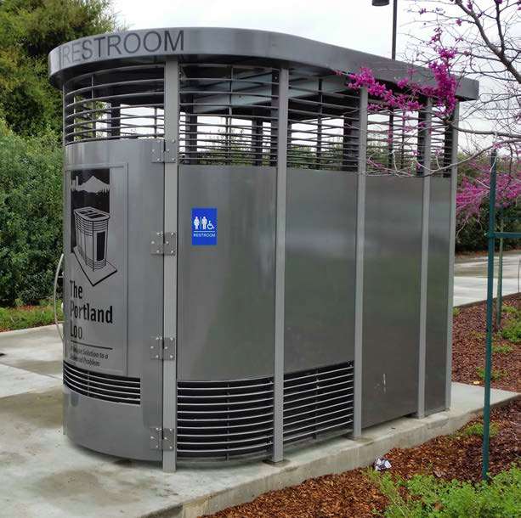  www.portlandloo.com | Designed using crime prevention measures to avoid being used for illicit activities and for easy maintenance.  Installed and successfully maintained in 23 cities in US and Canada; number of cities in US & growing.  Attractive  Open 24/7  Clean  Safe  $94,000 purchase/transport.  $32,000 - $38,000 installation if close to water/sewer lines  $12,000 -$ 20,000/yr. maintenance

AUTOMATED PUBLIC TOILET (size of a parking space)

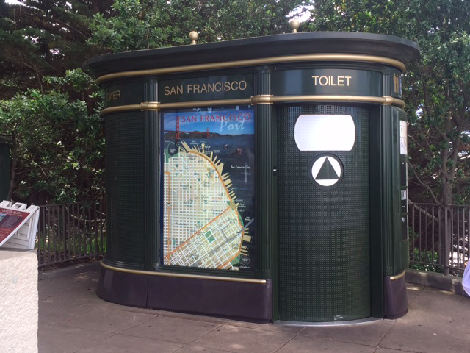  https://en.wikipedia.org/wiki/Sanisette | Found in New York City, San Francisco, many cities in Europe & Asia  Attractive  Open 24/7  Clean, issues in some locations  Safety issues in some locations  $250,000 - $1,000,000 purchase  $25,000 - $35,000 installation if close to water/sewer lines  $100,000 - $150,000/yr. maintenance

LONDON COMMUNITY TOILET SCHEME

https://www.cityoflondon.gov.uk/services/transport-and-streets/clean-streets/Pages/Community-Toilet-Scheme-(CTS).aspx | Government provides a financial  incentive (600 Euro/year) to private  businesses to make their toilets available  to public  Businesses display special stickers in  their windows  Signs indicate where they are located  75 participating businesses in downtown  London borough.  In use in other cities in England,  Germany, and throughout Australia

ATTACHMENT 3
Who the Restroom Challenged Are
(from the American Restroom Association website )

- Middle age women (NAFC)
- Pregnant women
- Parents touring with young children
- Children in School
- Women experiencing an irregular menses
- People suffering certain congenital defects
- Those with bladder cancer (2)
- Some wounded Combat Veterans
- Victims of abdominal or nerve trauma
- Women being treated for Vaginal Candidiasis *
- 10 to 40% of Stroke victims
- Otherwise healthy persons suffering bowel incontinence
- People with Interstitial Cystitis
- Those suffering Irritable Bowel Syndrome, Ulcerative Colitis
- The Elderly (functional capacity is halved as we age.)
- Patients suffering the diuretic effect of blood pressure medicine
- Men suffering an enlarged prostate
- Diners experiencing the diuretic effect of coffee or alcohol
- Patients on medications that act as bowel or bladder irritants
- Ostomy pouches require prompt attention when at capacity

J. Schmidt, J and Brubaker, R. The Code and Practice of Toilets in the United States of America, www.americanrestroom.org/wto/wts04_paper.pdf
Nielsen, A. Waite, W., "Epidemiology of Infrequent Voiding and Associated Symptoms," Scandinavian Journal of Urology and Nephrology. Supplemented 157, pg.49-53, January 1994
National Institutes of Health (NJH) Publication No. 95-2754, July 1995.
https://www.agingcare.com/articles/urinary-tract-infections-elderly-146026.htm
https://www.nia.nih.gov/health/urinary-incontinence-older-adults
https://www.aboutincontinence.org/incontinence-and-aging.html
http://www.who.int/water_sanitation_health/hygiene/emergencies/em2002chap8.pdf
Matt Russell, Ph.D. in Biochemistry, Cellular and Molecular Biology from the University of Tennessee
Preferred by PFFC Downtown DC Public Restroom Initiative based on research on lessons learned/best practices elsewhere: designed using crime prevention measures (louvers so can see and hear what is happening inside, lighting inside and outside at night, blue light to discourage needle use), lower cost to install and maintain (utilities are solar powered, 1.25-gallon flush, easier to keep clean., maximizes use by not having hand wash on outside.
https://americanrestroom.org/pr/who.htm

